KARNATAK LAW SOCIETY’S GOGTE INSTITUTE OF TECHNOLOGY

UDYAMBAG, BELGAVI-590008

(An Autonomous Institution under Visvesvaraya Technological University Belagavi)

# (APPROVED BY AICTE, NEW DELHI)



Course Activity Report On

# Modeling an Anti-Lock Braking System

*Submitted in the partial fulfilment for the academic requirement of*

**6th Semester B.E in**

Submitted by

|  |  |
| --- | --- |
| **NAME OF THE CANDIDATE** | **USN** |
| Anish Katti | 2GI20EC022 |
| Chidambar Kulkarni | 2GI20EC037 |
| Laxman Kalyani | 2GI20EC060 |
| Abhishek naik | 2GI20EC006 |

**GUIDED BY**

**Prof. Praveen kalkundri**

**INDEX**

* INTRODUCTION
* ANALYSIS AND PHYSICS
* MODELLING
* OPENING THE MODEL
* RUNNING AND SIMULATION IN ABS MODE
* RUNNING AND SIMULATION WITHOUT ABS
* BRAKING WITH ABS VERSES BRAKING WITHOUT ABS
* ADAVANTAGE OF ABS
* DISADAVANTAGE OF ABS
* APPLICATION OF ABS
* CONCLUSION
* REFERENCE

**INTRODUCTION**

A safety device called the Anti-Lock Braking System (ABS) is intended to keep wheels from locking up when a vehicle is braking. It is a crucial component of contemporary vehicle braking systems and considerably enhances the ability of the car to stop and maintain control in emergency or heavy braking circumstances. The driver would physically press down on the brake pedal to activate hydraulic brake lines, which would then convey the driver's force to the wheel brakes before the invention of ABS. However, when braking quickly or forcefully, the wheels may lock up and lose grip with the ground. Skidding, loss of steering control, and an elevated risk of accidents might result from this wheel lock-up. A safety device called the Anti-Lock Braking System (ABS) is intended to keep wheels from locking up when a vehicle is braking. It is a crucial component of contemporary vehicle braking systems and considerably enhances the ability of the car to stop and maintain control in emergency or heavy braking circumstances. The driver would physically press down on the brake pedal to activate hydraulic brake lines, which would then convey the driver's force to the wheel brakes before the invention of ABS. However, when braking quickly or forcefully, the wheels may lock up and lose grip with the ground. Skidding, loss of steering control, and an elevated risk of accidents might result from this wheel lock-up.

### **Analysis and Physics**

The wheel rotates with an initial angular speed that corresponds to the vehicle speed before the brakes are applied. We used separate integrators to compute wheel angular speed and vehicle speed. We use two speeds to calculate slip, which is determined by Equation 1. Note that we introduce vehicle speed expressed as an angular velocity (see below).

$$\omega_v = \frac{V}{R} \mbox{ (equals the wheel angular speed if there is no slip)}$$

**Equation 1**

$$ \omega_v = \frac{V_v}{R_r}$$

$$slip=1-\frac{\omega_w}{\omega_v}$$

$$\omega_v = \mbox{ vehicle speed divided by wheel radius}$$

$$ V_v = \mbox{ vehicle linear velocity}$$

$$ R_r = \mbox{ wheel radius}$$

$$ \omega_w = \mbox{ wheel angular velocity}$$

From these expressions, we see that slip is zero when wheel speed and vehicle speed are equal, and slip equals one when the wheel is locked. A desirable slip value is 0.2, which means that the number of wheel revolutions equals 0.8 times the number of revolutions under non-braking conditions with the same vehicle velocity. This maximizes the adhesion between the tire and road and minimizes the stopping distance with the available friction.

### **Modelling**

The friction coefficient between the tire and the road surface, mu, is an empirical function of slip, known as the mu-slip curve. We created mu-slip curves by passing MATLAB variables into the block diagram using a Simulink lookup table. The model multiplies the friction coefficient, mu, by the weight on the wheel, W, to yield the frictional force, Ff, acting on the circumference of the tire. Ff is divided by the vehicle mass to produce the vehicle deceleration, which the model integrates to obtain vehicle velocity.

In this model, we used an ideal anti-lock braking controller, that uses 'bang-bang' control based upon the error between actual slip and desired slip. We set the desired slip to the value of slip at which the mu-slip curve reaches a peak value, this being the optimum value for minimum braking distance (see note below.).

Note: In an actual vehicle, the slip cannot be measured directly, so this control algorithm is not practical. It is used in this example to illustrate the conceptual construction of such a simulation model. The real engineering value of a simulation like this is to show the potential of the control concept prior to addressing the specific issues of implementation.

### **Opening the Model**

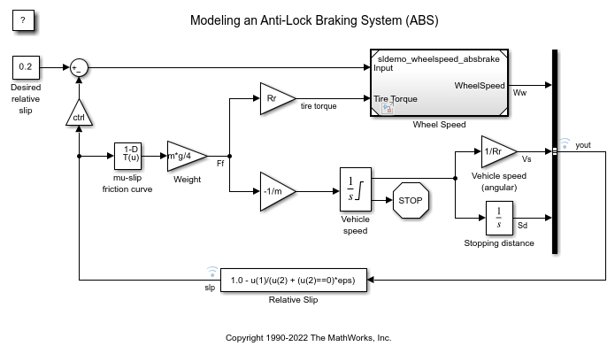

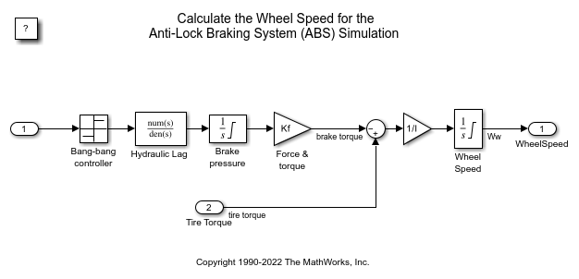

To control the rate of change of brake pressure, the model subtracts actual slip from the desired slip and feeds this signal into a bang-bang control (+1 or -1, depending on the sign of the error). This on/off rate passes through a first-order lag that represents the delay associated with the hydraulic lines of the brake system. The model then integrates the filtered rate to yield the actual brake pressure. The resulting signal, multiplied by the piston area and radius with respect to the wheel (Kf), is the brake torque applied to the wheel.

The model multiplies the frictional force on the wheel by the wheel radius (Rr) to give the accelerating torque of the road surface on the wheel. The brake torque is subtracted to give the net torque on the wheel. Dividing the net torque by the wheel rotational inertia, I, yields the wheel acceleration, which is then integrated to provide wheel velocity. In order to keep the wheel speed and vehicle speed positive, limited integrators are used in this model.

### **Running the Simulation in ABS Mode**

On the Simulation tab, click **Run** to run the simulation. You can also run the simulation by executing the sim('sldem\_absbrake') command in MATLAB. ABS is turned on during this simulation.

You can do this by generating real-time C code for this model using the Simulink Coder. You can then test an actual ABS controller by interfacing it to the real-time hardware, which runs the generated code. In this scenario, the real-time model would send the wheel speed to the controller, and the controller would send brake action to the model.

For a hardware-in-the-loop braking system simulation, you can remove the 'bang-bang' controller and run the equations of motion on real-time hardware to emulate the wheel and vehicle dynamics. You can do this by generating real-time C code for this model using the Simulink Coder

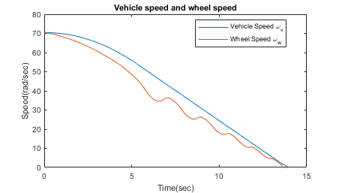

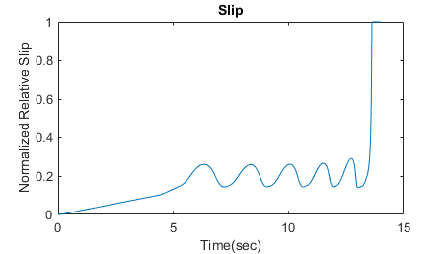

Note: The model logs relevant data to MATLAB workspace in a structure called seldom\_ abs brake\_ output. Logged signals have a blue indicator. In this case out and slip are logged. Read more about Signal Logging in Simulink Help.

The plots above show the ABS simulation results (for default parameters). The first plot shows the wheel angular velocity and corresponding vehicle angular velocity. This plot shows that the wheel speed stays below vehicle speed without locking up, with vehicle speed going to zero in less than 15 seconds

### **Running the Simulation Without ABS**

For more meaningful results, consider the vehicle behaviour without ABS. At the MATLAB command line, set the model variable ctrl = 0. This disconnects the slip feedback from the controller, resulting in maximum braking.

ctrl = 0;

Now run the simulation again. This will model braking without ABS.

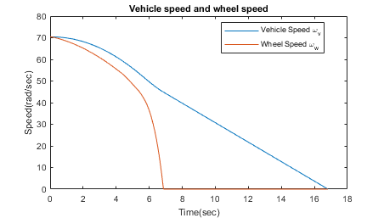

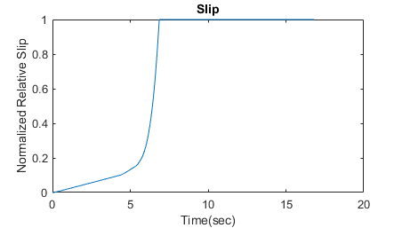

### **Braking With ABS Versus Braking Without ABS**

In the plot showing vehicle speed and wheel speed, observe that the wheel locks up in about seven seconds. The braking, from that point on, is applied in a less-than-optimal part of the slip curve. That is, when slip = 1, as the slip plot shows, the tire is skidding so much on the pavement that the friction force has dropped off.

This is, perhaps, more meaningful in terms of the comparison shown below. The distance traveled by the vehicle is plotted for the two cases. Without ABS, the vehicle skids about an extra 100 feet, taking about three seconds longer to come to a stop.

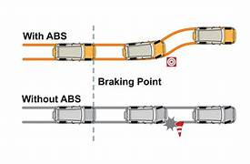

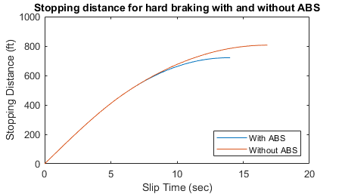

**Advantage of Antilock braking system**

* Greater Vehicle Control: During braking, ABS aids the driver in maintaining greater control of the vehicle. ABS lowers the likelihood of sliding or losing control of the vehicle by avoiding wheel lock-up and enabling effective steering input
* Shorter Stopping Distances: ABS allows the driver to brake as hard as possible while still having steering control. Due to reduced stopping distances, particularly on slick or low-traction terrain, accidents may be avoided.
* Increased Stability: ABS's capacity to independently vary braking pressure to each wheel contributes to the upkeep of vehicle stability. It stops the car from veering or swerving erratically when braking hard, which can be extremely important in emergency situations.
* Improved Traction: By reducing wheel lock-up, ABS increases the traction between the tyres and the road surface. This makes it possible for the tyres to keep better contact with the pavement, resulting in improved braking performance.

**Disadvantage of Antilock braking system**

* Increased Stopping Distance on Loose Surfaces: When stopping on loose surfaces like deep snow or rough gravel, ABS may require more stopping distance than without it. This is due to the possibility that ABS will prevent the wheels from sinking into the slick surface and producing enough resistance for efficient braking.
* Pedal Feedback: The brake pedal may vibrate or pulse when ABS is used, and the driver may lose pedal feel. For some drivers who are not used to these sensations, this can be unsettling and may cause them to feel less in control of their vehicle.
* ABS is a complicated and expensive system that calls for extra parts including wheel speed sensors, control units, and hydraulic valves. Installation, upkeep, and repair of ABS might be more complicated
* Increased Maintenance Needs: ABS parts like wheel speed sensors might be vulnerable to deterioration or failure. To guarantee the ABS system is operating properly, routine maintenance and inspection are required. The ABS system may not operate as intended if its components are not maintained.

**Application of ABS**

The Anti-Lock Braking System (ABS) is widely used in a variety of vehicles, including motorcycles, commercial trucks, and passenger automobiles. Its main goal is to increase safety and braking performance in various driving situations. Here are a few prominent uses of ABS:

* + Automobiles: ABS is frequently used in passenger vehicles of many shapes and sizes, such as sedans, SUVs, and hatchbacks. When braking in an emergency, it aids drivers in maintaining control, especially on slick or uneven roads.
  + Commercial trucks and buses: ABS are essential for big, heavy-duty commercial vehicles. This decreases the possibility of these cars sliding or jack-knifing during braking manoeuvres by improving their stability and control.
  + motorbikes: To avoid wheel lock-up and probable sliding while braking, ABS is being used more and more in motorbikes. Rider safety is improved by this technology, especially in urgent situations or while braking on uneven or slick conditions.
  + Off-Road Vehicles: Off-road vehicles, such as 4x4s and SUVs made for rough terrain, can use ABS. When braking off-road, it aids in preventing wheel lock-up, enabling the driver to maintain control and traction on varying conditions.
  + Emergency vehicles, such as police cars, ambulances, and fire engines, require ABS in order to function. It helps preserve stability and control during rapid braking or manoeuvres at high speeds, allowing these vehicles to go through traffic safely.

### **Conclusions**

This model shows how you can use Simulink to simulate a braking system under the action of an ABS controller. The controller in this example is idealized, but you can use any proposed control algorithm in its place to evaluate the system's performance. You can also use the Simulink® Coder™ with Simulink as a valuable tool for rapid prototyping of the proposed algorithm. C code is generated and compiled for the controller hardware to test the concept in a vehicle. This significantly reduces the time needed to prove new ideas by enabling actual testing early in the development cycle.

For a hardware-in-the-loop braking system simulation, you can remove the 'bang-bang' controller and run the equations of motion on real-time hardware to emulate the wheel and vehicle dynamics. You can do this by generating real-time C code for this model using the Simulink Coder. You can then test an actual ABS controller by interfacing it to the real-time hardware, which runs the generated code. In this scenario, the real-time model would send the wheel speed to the controller, and the controller would send brake action to the model.

**Reference**

**Title:** “Automotive Chassis: Brakes, Suspension, and Steering” **Author:** Tim Gilles publisher: Cengage Learning **Year:** 2014

.